Ali -- I changed them to brothers – two consecutive ticket numbers, same fare, same embarkation, 3rd class, both non survivors

The Cacic family – original file did not have them connected, I filled in 3 sibsp for each of them. Ticket numbers close, same fare, same embarkation, 3rd class (2 non survivors 1 male 1 female, 2 in test file)

Calic brothers – twins or cousins. I added a 1 for sibsp for each. Ticket numbers close, same fare, same embarkation, 3rd class, non survivors

Oreskovic siblings, changed from 0 to 2, 2 nonsurvivors, 1 unknown
ticket numbers close, same fare, same embarkation, 3rd class

Poknic siblings, changed from 0 to 1. Ticket numbers close, same fare, same embarkation,
3rd class, unknown survival (both)

Risien couple. Changed to Sibsp = 1 for both. On same ticket, spouses based on the name.

Changed Mrs John James to 1 for Sibsp, and changed Mr. John James to 2 (for sibling)

Mother-daughter, same ticket, changed Parch to 1 for both, 1 survived, 1 unknown

created siblings, non survivors, 3rd class, ticket numbers close, same fare, same embarkation

Assumed these 2 are brothers, changed to Sibsp = 1

I changed Parch from 3 to 2 for Ford, William Neal only – he's 16, no infant noted, max 2 parents – he has 2 siblings and 2 parents

Family unit all on same ticket (Arthur Ford not included), 4 non-survivors, 1 unknown

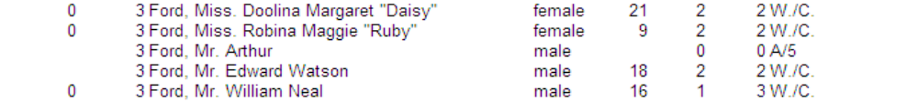

changed sibsp to 1 for August Victor, Larsson consecutive ticket with Ahlin, only matching spouse/sibling for her

**************************************************************************

Ones that I didn't change, but maybe should have

ticket numbers close, same embarkation
one non survivor, one unknown
ticket numbers NOT so close, same embarkation

one survived, one unknown

consecutive ticket numbers
Svend shows sibsp, but no one matched to him
All non-survivors

